Eviction Notice Instructions
Your eviction notice template starts on the next page. To get step-by-step instructions on how to fill out this eviction notice, please follow the instructions below.
Step 1. Search for “FormSwift Eviction Notice”
Search for “formswift eviction notice” on https://google.com and click the link that reads https://formswift.com/eviction-notice.
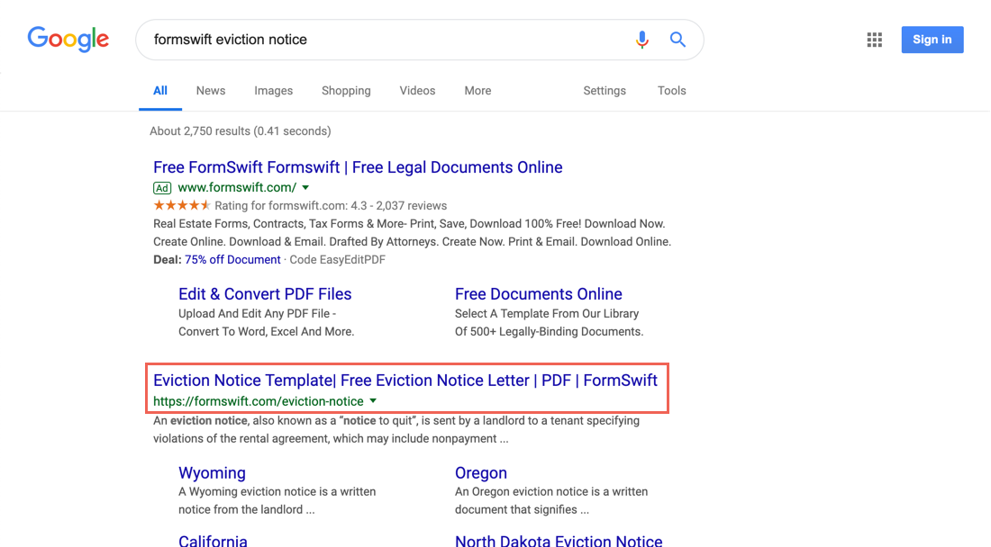
Step 2. Find the Step-by-Step Section
Scroll down until you see the Step-by-Step section on the page. It should look something like below.
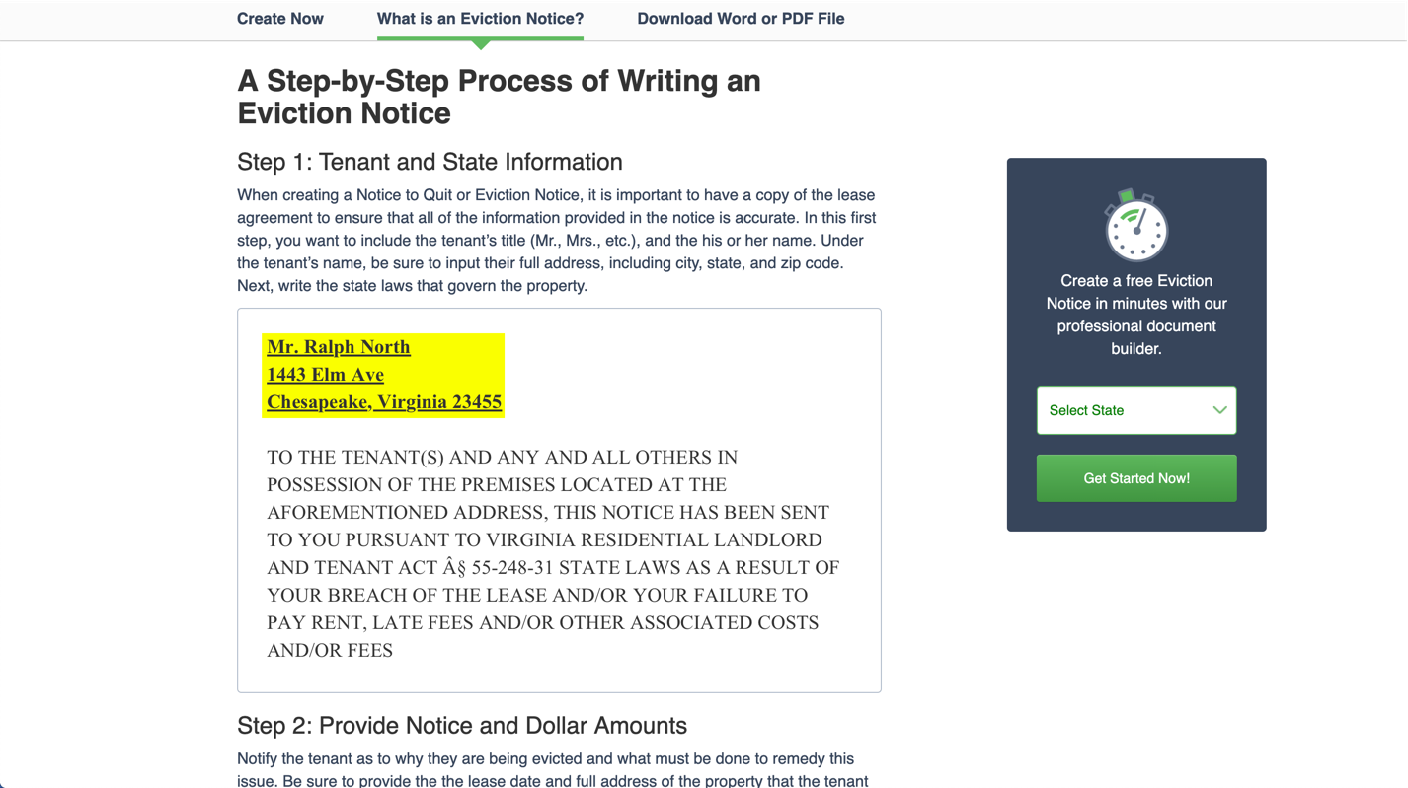
Step 3. Follow the Steps in the Guide
Review each step and decide what is the best way to fill out for your specific scenario. If you find these steps helpful, feel free to share the guide by providing the proper attribution with a link to formswift.com/eviction-notice.
EVICTION NOTICE

________________________. ________________________
________________________
________________________, ________________________ ________________________

TO THE TENANT(S) AND ANY AND ALL OTHERS IN POSSESSION OF THE PREMISES LOCATED AT THE AFOREMENTIONED ADDRESS, THIS NOTICE HAS BEEN SENT TO YOU PURSUANT TO ________________________ STATE LAWS AS A RESULT OF YOUR BREACH OF THE LEASE AND/OR YOUR FAILURE TO PAY RENT, LATE FEES AND/OR OTHER ASSOCIATED COSTS AND/OR FEES.

BE IT KNOWN that pursuant to your signed Lease Agreement dated ________________________ and where you are in possession of the premises located at ________________________, ________________________, ________________________ ________________________, there is currently past due, unpaid and delinquent rent and/or fees in the total amount of ________________________. The total amount past due is representative of unpaid rent from ________________________ to ________________________, plus any late fee charges and/or interest accrued on the past due rent.

THEREFORE, you are hereby provided notice that all past due monies must be paid in full by no later than ________________________ or you must vacate, quit, relinquish, move out or deliver up possession of the aforementioned premises. Failure to correct the breach of your Lease Agreement by making payment in full within the stipulated time requested by this notice shall result in the cancellation, termination or forfeiture of the Lease Agreement.

THE LANDLORD RESERVES THE RIGHTS AND REMEDIES AFFORDED TO THEM PURSUANT TO THE SIGNED LEASE/RENTAL AGREEMENT AND IN ACCORDANCE WITH APPLICABLE LAWS OF THE STATE OF ________________________ INCLUDING, BUT NOT LIMITED TO, UNPAID RENT AND/OR PROPERTY DAMAGES, AND NOTHING IN THIS NOTICE MAY BE INTERPRETED AS A RELINQUISHMENT OF SUCH RIGHTS AND REMEDIES.

By: | ___________________________________________________  (Landlord Signature) | ___________________  (Date)
 | ________________________. ________________________
 | ________________________
 | ________________________, ________________________ ________________________
 | ________________________
 | ________________________

CERTIFICATE OF SERVICE

BE IT KNOWN that I, ________________________, hereby certify that on the date of ______________, I served copies of the Eviction Notice on ________________________. ________________________ by way of ________________________.

___________________________________________________  (Landlord Signature) | ___________________  (Date)
________________________. ________________________
________________________
________________________, ________________________ ________________________
________________________
________________________

