Last Will and Testament Instructions
Your last will and testament template starts on the next page. To get step-by-step instructions on how to fill out this last will and testament, please follow the instructions below.
Step 1. Search for “FormSwift Last Will and Testament”
Search for “formswift last will and testament” on https://google.com and click the link that reads https://formswift.com/last-will-and-testament.
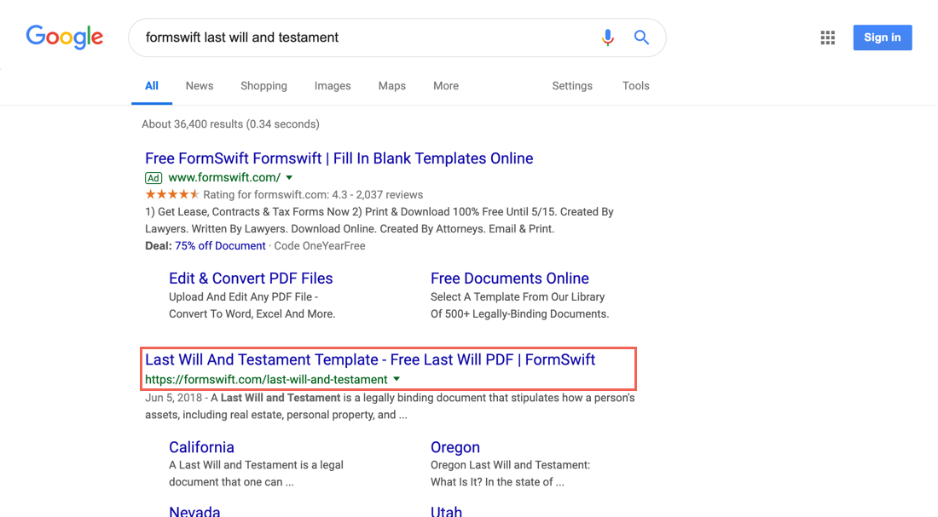
Step 2. Find the Step-by-Step Section
Scroll down until you see the Step-by-Step section on the page. It should look something like below.
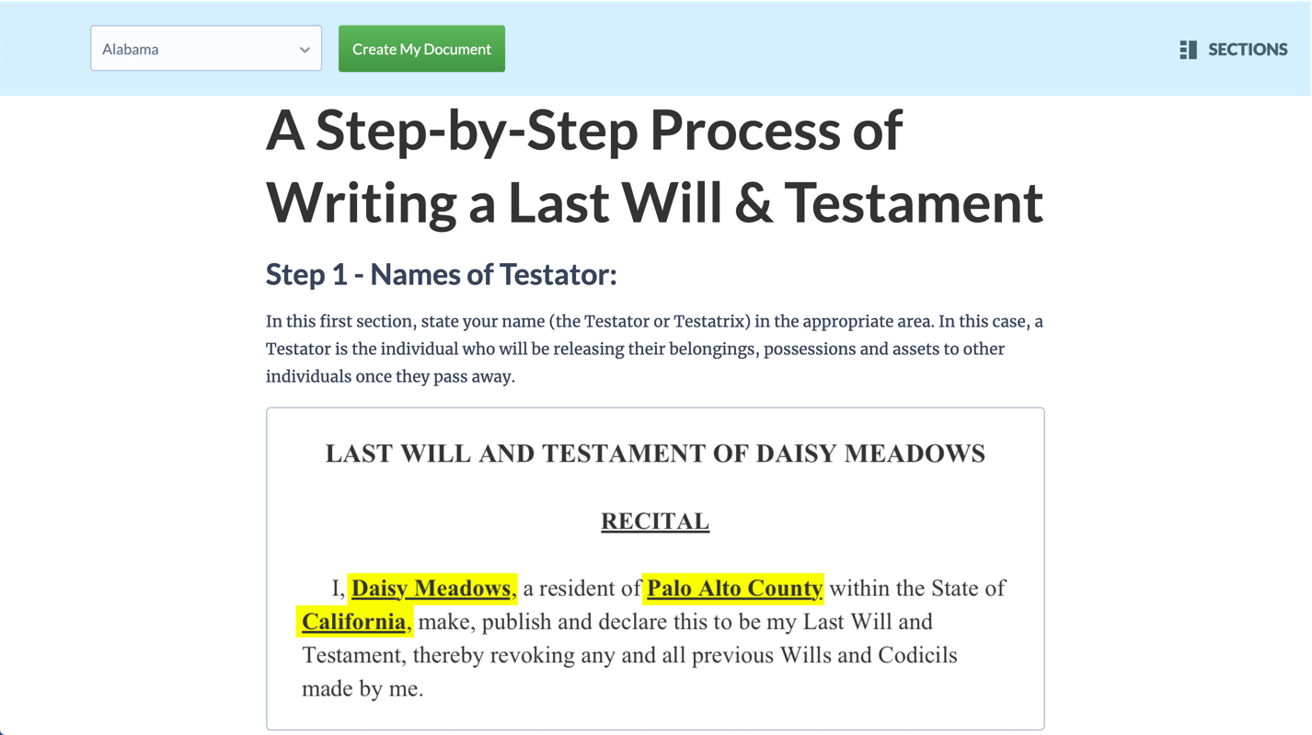
Step 3. Follow the Steps in the Guide
Review each step and decide what is the best way to fill out for your specific scenario. If you find these steps helpful, feel free to share the guide by providing the proper attribution with a link to formswift.com/last-will-and-testament.
LAST WILL AND TESTAMENT
OF
________________________

RECITAL

I, ________________________, a resident of ________________________ County within the State of ________________________, make, publish and declare this to be my Last Will and Testament, thereby revoking any and all previous Wills and Codicils made by me.

RELATIVES

I, ________________________, attest that I am ________________________.

All references in this Will to the Descendants of any person shall mean their naturally born children and/or legally adopted children, unless otherwise indicated, as well as any of their children's naturally born and/or legally adopted children throughout the generations to come.

BURIAL

All costs and expenses associated with my burial requests shall be paid from the life insurance, if any, and/or proceeds of my estate.

DEBTS & EXPENSES

Any and all my debts due and payable, including funeral, memorial and burial expenses, the expenses of the administration of my estate, all estate, inheritance and similar taxes payable with respect to property included in my probate estate, including any interest and/or penalties thereon, shall be paid out of my estate pursuant with the laws of the State of ________________________, without apportionment or right of reimbursement from any beneficiary herein named in my Will.

PERSONAL PROPERTY

I bestow all of my tangible personal property owned by me at the time of my death, including, without limitation, personal effects, clothing, jewelry, furniture, furnishings, household goods, automobiles and other vehicles, along with all insurance policies upon such tangible property, in accordance to those designated in the attached Schedule - Beneficiary Designations, and if any of them shall be under the age of eighteen (18) years, then it shall be held in trust until such time as (s)he becomes of age.

As per the attached Schedule - Beneficiary Designations to this Will, signed by me and identifying certain personal property which is to be bestowed upon the persons named therein, I direct my Executor to distribute such property in accordance with the terms and provisions contained herein.

The reasonable fee of delivering such property shall be paid by my Executor as an expense of my estate.

CASH, BANK ACCOUNTS, INVESTMENTS

I bestow and bequeath any interest which may belong to me at the time of my death in accordance to and in conjunction with the attached Schedule - Beneficiary Designations and a separately prepared account listing that details checking and savings accounts, certificates of deposit, cash, checks, notes and/or promissory notes designees.

RESIDUARY ESTATE

I bestow and bequeath all the rest, residue and remainder of my property and estate, both real and personal, of whatever kind and wherever located, including any inheritance I may be entitled to as well as any lapsed or void legacy or devise under this Will, that I own or am in any manner entitled to at the time of my death (collectively referred to as my "residuary estate"), to be divided among those as designated in the attached Schedule - Beneficiary Designations. If they are or if any of them shall be under the age of eighteen (18) years, then it shall be held in trust until such time as s/he becomes of age.

If there should be no living beneficiary under the above provisions to receive the assets in my residuary estate, then my residuary estate shall be distributed to the persons who would be entitled thereto under the laws of descent and distribution pursuant to the laws of the State of ________________________, as if I had died intestate at that time owning such property in fee simple.

TESTAMENTARY TRUST

Any property, assets or other distributions from my estate intended for a beneficiary under 18 years of age at the time of distribution is to be made, shall not be paid or distributed outright to such beneficiary, but rather shall be held in trust by my Trustee, or if I have not named a Trustee, by my Executor in the capacity of a Trustee, upon the following terms and conditions.

The Trustee shall hold, manage, invest and reinvest the property of such beneficiary in a separate trust and shall distribute to or for the benefit of the beneficiary so much or all of the net income or principal thereof as the Trustee, in the Trustee's sole discretion, shall deem necessary to provide for such beneficiary's health, education, maintenance and support, taking into consideration any other resources available to such beneficiary. Any net income not so paid shall be accumulated and added to principal at least annually and thereafter shall be held, administered and disposed of as a part thereof.

When such beneficiary reaches ________________________ years of age, the Trustee shall distribute ________________________ of the assets then held in trust to such beneficiary; and if and when such beneficiary reaches ________________________ years of age, the Trust shall automatically terminate and the Trustee shall distribute all remaining principal and income to such beneficiary. Notwithstanding any provisions herein to the contrary, my Trustee may determine it is in the best interests of the beneficiary to terminate the trust prior to such beneficiary reaching ________________________ years of age and distribute all trust assets directly to such beneficiary or into a custodial account established for such beneficiary, and my Trustee shall have no liability therefore.

If such beneficiary dies prior to receiving all of the assets in his/her trust, the principal and income in such beneficiary's trust shall be paid and distributed to such beneficiary's living Descendants, if any; and if none, then to my living Descendants, provided, however, that if any such Descendant is a beneficiary of another trust under this Will, such property otherwise distributable to such beneficiary shall be held in accordance with such trust. If I have no living Descendants, such property shall be distributed to the beneficiaries of my residuary estate as provided in this Will, or if there are none, to the persons who would be entitled thereto under the laws of descent and distribution of the State of ________________________ if I had died intestate at that time owning such property in fee simple.

AVOIDANCE OF CONSERVATORSHIP

If any property of my estate vests in absolute ownership in a minor or incompetent, my Executor, at any time and without court authorization, may:

- distribute the whole or any part of such property to the beneficiary;

- hold such property in trust and use the whole or any part for the health, education, maintenance and support of the beneficiary;

- distribute the whole or any part to a guardian, conservator, committee or other legal representative of the beneficiary;

- distribute the whole or part to a custodian for the beneficiary under any gifts or transfers to minors act; or

- distribute the whole or part to the person or persons with whom the beneficiary resides.

Evidence of any such distribution or the receipt therefor executed by the person to whom the distribution is made shall be a full discharge of my Executor from any liability with respect thereto, even though my Executor may be such person.

If such beneficiary dies before receiving all of the assets held in conservancy, the principal and income in such beneficiary's trust shall be paid and distributed to such beneficiary's living Descendants, if any; and if none, then to my living Descendants. If I have no living Descendants, such property shall be distributed to the beneficiaries of my residuary estate, as provided in this Will, or if there none, to the persons who would be entitled thereto under the laws of descent and distribution of the State of ________________________ as if I had died intestate at that time owning such property in fee simple.

SPENDTHRIFT PROVISION

The interest of any beneficiary of any trust created under this Will shall not be transferred, assigned or conveyed, and shall not be subject to the claims of any creditors of such beneficiary, or of any local, state or federal government or agency, or of any private agencies, and the Trustee, or if I have not named a Trustee, by my Executor in the capacity of a Trustee, shall continue distributing trust property directly to or for the benefit of such beneficiary as provided for herein, notwithstanding any transfer, assignment, conveyance or action by creditors governments or agencies. If the Trustee is prevented by any transfer, assignment or conveyance or by any proceeding brought by any creditor, government or agency or by any bankruptcy, receivership or other proceeding, from distributing property directly to or for the benefit of any beneficiary, the Trustee shall hold and accumulate the property which would otherwise have been distributed until the Trustee is able to distribute such property directly to or for the benefit of such beneficiary, or until the death of such beneficiary, whichever first occurs; and on the death of such beneficiary any such property so held and accumulated shall become a part of the principal of the trust and shall be disposed of accordingly.

APPOINTMENT OF EXECUTOR/TRUSTEE

BONDS/AUDITS NOT REQUIRED

The term "Fiduciary" shall mean any Executor, Trustee or successor qualifying and serving under this Will.

No Fiduciary shall be required to file or furnish any bond, surety or other security in any jurisdiction, nor shall any Fiduciary hereunder be required to file any inventory or other reports with any court.

No Fiduciary shall be required to inquire into or audit the acts or doings of any predecessor Fiduciary or to make claim against any such predecessor or their estate.

POWERS OF EXECUTORS/TRUSTEES

Any Executor or Trustee serving under this Will shall be a Fiduciary granted all the powers conferred by ________________________ laws, as amended.

Any successor Fiduciary shall have and may exercise all of the powers, privileges, immunities and exemptions conferred upon the predecessor Fiduciary as fully and to the same extent as if such successor had originally been named as a Fiduciary. Any Fiduciary serving hereunder shall keep full accounts and shall make and furnish statements of all receipts and disbursements at least annually to each person then eligible to receive income from my estate or any trust created hereunder and shall at any time, upon reasonable request of such person, provide full information to such person as to the condition of my estate, including amounts received and disbursements made.

Any Fiduciary under this Will may resign without the order of any officer or court and without consent of any beneficiary of any provision of this Will by giving such Fiduciary's successor and all persons then entitled to receive income hereunder, or the guardians of such persons, thirty (30) days advance written notice of such intent to resign, or at any time resign by instrument in writing signed by such Executor or Trustee and delivered to the persons then entitled to the income from my estate or such trust. In the case of an Executor, the Fiduciary must also give notice to the Court having jurisdiction over the administration of my estate; and upon properly accounting for all estate property received and disbursed, shall be discharged from any and all further liabilities. In the case of a Trustee, the Fiduciary must deliver the trust property to the successor Trustee and upon properly accounting for all trust property received and disbursed, shall be discharged from any and all further liabilities.

If a successor Fiduciary is unable or unwilling to serve, they may appoint a second successor Fiduciary to serve in their place, by sending a signed instrument appointing a successor delivered to each living beneficiary under my Will making express reference to this power and the second successor Fiduciary may exercise powers upon a prospective and contingent basis until effective:

To compensate counsel and to employ other persons who may be deemed necessary for proper administration and to delegate authority when delegation is advantageous to the trust or estate.

To exercise and continue the power provided in this section notwithstanding the termination of the trust until all assets of the trust has been distributed.

The right to receive reasonable compensation for services rendered with regards to this Will, and to be exonerated from and to pay all reasonable expenses and charges of the estate and trust.

SURVIVORSHIP

I direct that, for purposes of this Will, a beneficiary shall be deemed to predecease me unless such beneficiary survives me by more than thirty (30) days.

CONTESTS DISALLOWED

Should any beneficiary contest or initiate proceeding to contest the validity of this Will or to prevent any provision herein from being carried out in accordance with its terms (whether or not in good faith and with probable cause), then all the benefits provided for such contesting beneficiary in this Will, including their Descendants, shall be revoked and annulled.

The share to which such contesting beneficiary would otherwise have been entitled shall be distributed to such persons and in such manner as if such contesting beneficiary and all of such beneficiary's Descendants had died immediately prior to such division without exercising any power of appointment which they might otherwise have under this Will.

If all of the persons who are beneficiaries of this Will join in such contest or proceeding, my estate shall be distributed to any of those persons who are not contesting beneficiaries and who would otherwise be entitled thereto under the laws of descent and distribution of the State of ________________________, as if I had died intestate at that time owning such property in fee simple.

IN WITNESS WHEREOF, I have set my hand and seal on this date of _______________________.

(________________________ Signature)

TESTATION CLAUSE

The foregoing instrument was signed, sealed, published and declared by ________________________, the above named ________________________ to be such ________________________'s Last Will and Testament in our presence, all being at the same time, and we, at such ________________________'s request and in such ________________________'s presence and in the presence of each other, have subscribed our names as witnesses on the aforementioned date above.

_____________________________________  (First Witness Signature) | ____________________________________  (Second Witness Signature)
________________________ | ________________________
________________________ | ________________________
________________________ ________________________ ________________________ | ________________________ ________________________ ________________________
________________________ | ________________________

SELF-PROVING AFFIDAVIT

STATE OF ________________________

COUNTY OF ________________________

Before me, the undersigned authority, on this day personally appeared the ________________________, ________________________, and the witnesses, ________________________ and ________________________, whose names are subscribed to the annexed or foregoing instrument in their respective capacities, and all of said individuals being duly sworn, the ________________________ declared to me and to the witnesses in my presence that said instrument is the Last Will and Testament of the ________________________ and that the ________________________ had willingly made and executed it as the ________________________'s free act and deed for the purposes expressed therein. The witnesses, each on oath, stated to me in the presence and hearing of the ________________________ that the ________________________ had declared to them that the instrument is the ________________________'s Last Will and Testament and that the ________________________ executed the instrument as such and wished each of them to sign it as it as a witness; and under oath each witness stated further that the witness had signed the same as witness in the presence of the ________________________ and at the ________________________'s request; that the ________________________ was of sound mind and body.

(________________________ Signature)
(First Witness Signature)
(Second Witness Signature)

Sworn to and subscribed before me by the ________________________, ________________________, and witnesses, ________________________ and ________________________, on this date of ___________________________.

(Notary Public Signature)
My Commission Expires _____________________

SCHEDULE - BENEFICIARY DESIGNATIONS

BENEFICIARY NAME | RELATIONSHIP | BEQUEATHED INHERITANCE | INHERITANCE PERCENTAGE

(________________________ Signature)

