Lease Agreement Instructions
Your lease agreement template starts on the next page. To get step-by-step instructions on how to fill out this lease agreement, please follow the instructions below.
Step 1. Search for “FormSwift Lease Agreement”
Search for “formswift lease agreement” on https://google.com and click the link that reads https://formswift.com/lease-agreement.
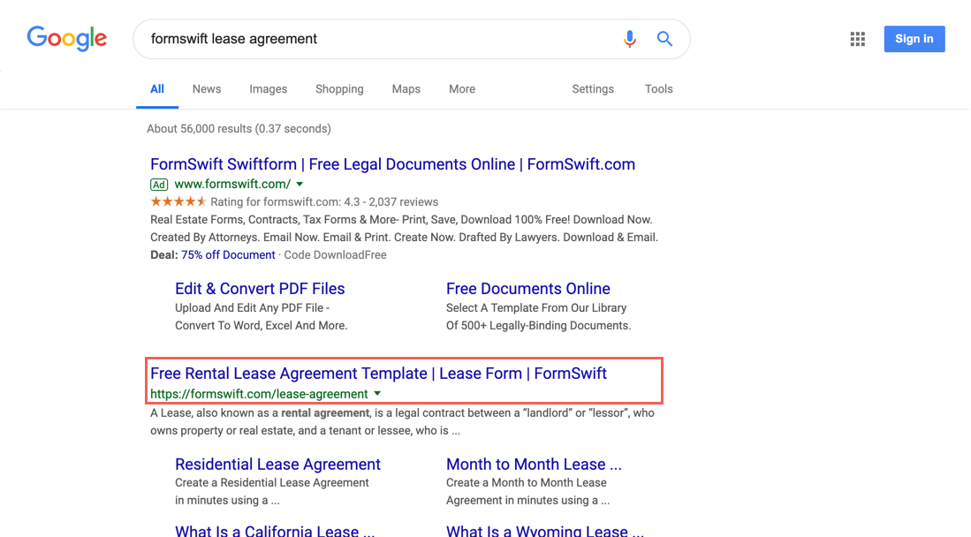
Step 2. Find the Step-by-Step Section
Scroll down until you see the Step-by-Step section on the page. It should look something like below.
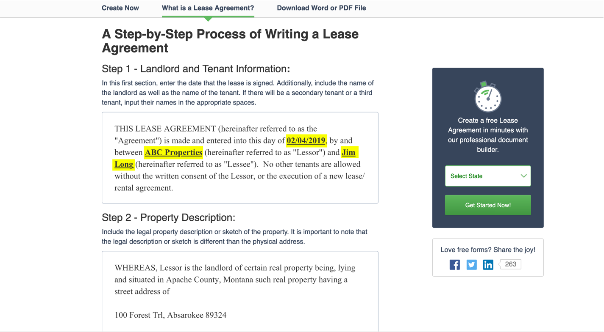
Step 3. Follow the Steps in the Guide
Review each step and decide what is the best way to fill out for your specific scenario. If you find these steps helpful, feel free to share the guide by providing the proper attribution with a link to formswift.com/lease-agreement.
RESIDENTIAL REAL ESTATE LEASE
THIS LEASE AGREEMENT (hereinafter referred to as the "Agreement") is made and entered into this day of ________________________, by and between ________________________ (hereinafter referred to as "Lessor") and ________________________ (hereinafter referred to as "Lessee"). No other tenants are allowed without the written consent of the Lessor, or the execution of a new lease/rental agreement.
W I T N E S S E T H:
WHEREAS, Lessor is the landlord of certain real property being, lying and situated in ________________________ County, ________________________ such real property having a street address of
________________________, ________________________ ________________________
The property is described as follows: ________________________ (hereinafter referred to as "Premises").
WHEREAS, Lessor is desirous of leasing the Premises to Lessee upon the terms and conditions as contained herein; and
WHEREAS, Lessee is desirous of leasing the Premises from Lessor on the terms and conditions as contained herein;
NOW, THEREFORE, the covenants and obligations contained herein and other good and valuable consideration, the receipt and sufficiency of which is hereby acknowledged, the parties hereto hereby agree as follows:
TERM. The lease term begins on ________________________, (hereinafter referred to as "Commencement Date") and shall terminate at 12 o'clock midnight on ________________________. Lessee shall vacate the premises upon termination of the Agreement, unless (i) Lessor and Lessee have extended this agreement or signed a new agreement; (ii) Lessor accepts rent from Lessee (other than past due rent), in which case a month-to-month tenancy shall be created which either party may terminate by a thirty (30) day written notice. In the event a month-to-month tenancy results, rent shall be at a rate agreed to by Lessor and Lessee, or as allowed by law; all other terms and conditions of this Agreement shall remain in full force and effect.
RENT. Rent shall mean all monetary obligations owed from Lessee to Lessor under the terms of this Agreement, except for security deposit, if any.
(1) Amount. The total rent for the term hereof is the sum of ________________________ per month for the term of the Agreement.
(2) Due Date. Rent is payable on the ________________________ day of each month of the term and can be late ________________________ days after aforementioned date.
(3) Commencement Date. Rent for the period beginning on the Commencement Date is due no later than seven (7) days prior to the commencement date. All other payments are to be paid as set forth in the Rent Section, paragraphs (1) and (2) above.
(4) Early Termination. In the event of early termination, Lessee is required to pay ________________________, or the remaining balance of the lease agreement, whichever is less, as an early termination fee.
(5) Payment Information. All such payments shall be made to Lessor at Lessor's address listed here: ________________________, ________________________, ________________________ ________________________ or any other location subsequently specified by Lessor in writing to Lessee, on or before the due date and without demand. If any payment is returned for non-sufficient funds, stop payment, or account closure by Lessee's bank, the Lessor may charge appropriate fees, as detailed in the Late Charge Section below.
DAMAGE TO PREMISES. If, by no fault of Lessee, Premises are totally or partially damaged or destroyed by fire, earthquake, flood, storm, accident, civil commotion, or other unavoidable cause so as to render the Premises totally or partially uninhabitable, either Lessor or Lessee may terminate this Agreement by giving the other written notice. Rent shall be prorated on the date the premises became totally or partially uninhabitable. The prorated amount shall be the current monthly Rent prorated on a thirty (30) day period. If the Agreement is not terminated, Lessor shall promptly repair the damage, and Rent shall be reduced based on the extent to which the damage interferes with Lessee's reasonable use of the Premises. If damage occurs as a result of an act of Lessee or Lessee's guests, only Lessor shall have the right of termination, and no reduction in Rent shall be made.
INSURANCE: Lessee's or guests' personal property and vehicles are not insured by Lessor against loss or damage due to fire, theft, vandalism, rain, water, criminal or negligent acts of others, or any other cause. Lessee is advised to carry Lessee's own insurance (Renter's Insurance) to protect Lessee from any such loss or damage. Lessee shall comply with any requirement imposed on Lessee by Lessor's insurer to avoid: (i) an increase in Lessor's insurance premium (or Lessee shall pay for the increase in premium); or (ii) loss of insurance.
The Lessor is responsible for paying and maintaining the following Rental Property taxes and insurances:

LATE CHARGE. Lessee acknowledges that late payment of Rent may cause Lessor to incur costs and expenses, the exact amount of which is extremely difficult and impractical to determine. These costs may include but are not limited to: processing, enforcement, accounting expenses and late charges imposed on the Lessor. Partial payments are not accepted. In the event that any payment required to be paid by Lessee hereunder is not made within ________________________ days, Lessee shall pay to Lessor, in addition to such payment or other charges due hereunder, a "late fee" in the amount of ________________________. Late fees are deemed additional Rent.
RETURNED CHECKS. Lessee acknowledges that the issuance of a returned check may cause Lessor to incur additional costs and expenses, the exact amount of which is extremely difficult and impractical to determine. If any payment is returned by the financial institution, for any reason, Lessor may require all future payments to be made in cash or by certified check. In addition, Lessee shall pay a ________________________ returned check fee. All fees, late fees, and service charges incurred by the Lessee as well as any expenses including reasonable attorney's fees incurred by Lessor in instituting and prosecuting any actions by reason of any default of Lessee hereunder shall be deemed to be additional rent and shall be due from Lessee to Lessor immediately following the incurring of the respective expenses, the nonpayment of which shall be a breach of this agreement for nonpayment of rent.
USE OF PREMISES. The Premises shall be used and occupied by Lessee and Lessee's immediate family, consisting of ________________________ people, exclusively, and no part of the Premises shall be used at any time during the term of this Agreement by Lessee for the purpose of carrying on any business, profession, or trade of any kind, or for any purpose other than as a private dwelling. Lessee shall not allow any other person, other than Lessee's immediate family or transient relatives and friends who are guests of Lessee, to use or occupy the Premises without first obtaining Lessor's written consent to such use. Lessee shall comply with any and all laws, ordinances, rules and orders of any and all governmental or quasi-governmental authorities affecting the cleanliness, use, occupancy and preservation of the Premises.

HOUSEHOLD MEMBERS AND GUESTS. Any additions to the household members named on the lease, including live-in aides and foster children, but excluding natural births, require the advance written approval of the Lessor. Such approval will be granted only if the new family members pass the Lessor's screening criteria and a unit of the appropriate size is available. Permission to add live-in aides and foster children shall not be unreasonably refused. Lessee agrees not to have the same overnight guest that has not passed the Lessor's screening criteria for more than ________________________ consecutive nights, and no more than a total of ________________________ nights per year.
CONDITION OF PREMISES. Lessee stipulates, represents and warrants that Lessee has examined the Premises, and that they are at the time of this Lease in good order, repair, and in a safe, clean and leasable condition. Lessee has examined and determined that all appliances and fixtures, if any, including smoke detector(s), are clean and in operable condition, within one month of move-in.
KEYS; LOCKS. The Lessee shall be issued ________________________ keys to the property and ________________________ keys to the mailbox by the Lessor at the signing of this Agreement. In the event the Lessee loses the keys that were issued at the signing of this agreement and the Lessee requests more keys from the Lessor, the Lessee will be required to pay in advance ________________________ per key requested.
(1)Lock Out. There will be a ________________________ charge for the second and each subsequent time Lessor is called to let any of the Lessees into the Premises, whatever the reason. The charge to unlock your door is ________________________ After Hours.
(2)Re-Keys Existing Locks. In the event Lessee re-keys existing locks or opening devices, Lessee shall immediately deliver copies of all keys to Lessor. Lessee shall pay all costs and charges related to loss of any keys or opening devices. Lessee may not remove locks, even if installed by Lessee.
ASSIGNMENT AND SUB-LETTING. Lessee shall not assign this Agreement, or sub-let or grant any license to use the Premises or any part thereof without the prior written consent of Lessor. Unless such consent is obtained, any assignment, transfer or subletting of Premises or this Agreement or tenancy, by voluntary act of Lessee, operation of law or otherwise, shall, at the option of Lessor, terminate this Agreement. Any proposed assignee, transferee or sub-lessee shall submit to Lessor an application and credit information for Lessor's approval and, if approved, sign a separate written agreement with Lessor and Lessee. Lessor's consent one such assignment, sub-letting or license shall not be construed as consent to any subsequent assignment, transfer or sublease and does not release Lessee or Lessee's obligations under this Agreement. An assignment, sub-letting or license without the prior written consent of Lessor or an assignment or sub-letting by operation of law shall be absolutely null and void and shall, at Lessor's option, terminate this Agreement.
ALTERATIONS AND IMPROVEMENTS. Lessee shall make no alterations to the buildings or improvements on the Premises or construct any building or make any other improvements on the Premises without the prior written consent of Lessor. Any and all alterations, changes, and/or improvements built, constructed or placed on the Premises by Lessee shall, unless otherwise provided by written agreement between Lessor and Lessee, be and become the property of Lessor and remain on the Premises at the expiration or earlier termination of this Agreement. Lessor may charge Lessee for restoration of the Premises to the condition it was in prior to any alterations/improvements. Lessee shall not make any repairs, alternations, or improvements in or about the Premises including: painting, wallpapering, adding or changing locks, installing antenna or satellite dish(es), placing signs, displays or exhibits, or using screws, fastening devices, large nails or adhesive materials. Lessor shall not be responsible for costs of alternations or repairs made by Lessee. Lessee shall not deduct from Rent the costs of any repairs, alternations or improvements and any deduction made by Lessee shall be considered unpaid Rent.
NON-DELIVERY OF POSSESSION. Lessee is not in position of the Premises. In the event Lessor cannot deliver possession of the Premises to Lessee upon the Commencement Date, such Date shall be extended to the date on which possession is made available to Lessee. If non-delivery of possession is through no fault of Lessor or its agents, then Lessor or its agents shall have no liability, but the rental herein provided shall abate until possession is given. Lessor or its agents shall have thirty (30) days in which to give possession, and if possession is tendered within such time, Lessee agrees to accept the demised Premises and pay the rental herein provided from that date. In the event possession cannot be delivered within such time, through no fault of Lessor or its agents, then Lessee may terminate this Agreement by giving written notice to Lessor, and Lessee shall be refunded all Rent and security deposit paid. Possession is deemed terminated when Lessee has returned all keys to the Premises to Lessor.
HAZARDOUS MATERIALS. Lessee shall not keep on the Premises any item of a dangerous, flammable or explosive character that might unreasonably increase the danger of fire or explosion on the Premises or that might be considered hazardous or extra hazardous by any responsible insurance company.
LEAD-BASED PAINT DISCLOSURE. This property built before 1978. Housing built before 1978 may contain lead-based paint. Lead paint, paint chips and dust can cause health hazards if not managed properly. Lead exposure is especially harmful to young children and pregnant women. Before renting pre-1978 housing, Lessors must disclose the presence of lead-based paint hazards in the dwelling. Renters must also receive a federally-approved pamphlet on lead poisoning prevention.
UTILITIES. ________________________ shall be responsible for arranging and paying for all utility services required on the Premises.
STORAGE. Storage is permitted as follows: Lessee shall store only personal property Lessee owns, and shall not store property claimed by another or in which another has any right, title or interest. Lessee shall not store any improperly packaged food or perishable goods, flammable materials, explosives, hazardous waste or other inherently dangerous material, or illegal substances.
VEHICLES/PARKING. Parking is permitted as follows: Parking is to be used only for properly licensed and operable motor vehicle. NO trailers, boats, campers, recreational vehicles, busses, trucks or unregistered vehicles are to be brought on the premises. NO parking or driving on the property lawn or neighbor's lawns or driveway is permitted. Any cars found parked on the lawn will be towed at Lessee's expense. Parking space is to be kept clean and cars must be parked in an orderly fashion. Mechanical work or storage of inoperable vehicles in not permitted in garage or parking space or elsewhere on the Premises. The Lessor, at the Lessees expense, may remove disabled vehicles and unregistered vehicles at any time. NO vehicle maintenance may be performed on the property (i.e. oil changes, brake changes, etc.). Town parking restrictions must be followed.
NEIGHBORHOOD CONDITIONS. Lessee is advised to satisfy Lessee's self as to neighborhood or area conditions, including: schools, proximity and adequacy of law enforcement, crime statistics, proximity of registered felons or offenders, fire protection, other governmental services, availability, adequacy and cost of any speed-wired, wireless internet connections or other telecommunications or other technology services and installations, proximity to commercial, industrial or agricultural activities, existing and proposed transportation, construction and development that may affect noise, view, or traffic, airport noise, noise or odor from any source, wild and domestic animals, other nuisances, hazards, or circumstances, cemeteries, facilities and condition of common areas, conditions and influences of significance to certain cultures and/or religions, and personal needs, requirements and preferences of Lessee.
TEMPORARY RELOCATION. Subject to local law, Lessee agrees, upon demand of Lessor, to temporarily vacate Premises for a reasonable period, to allow for fumigation (or other methods) to control wood destroying pests or organisms, or other repairs to Premises. Lessee agrees to comply with all instructions and requirements necessary to prepare Premises to accommodate pest control, fumigation or other work, including bagging or storage of food and medicine, and removal of perishables and valuables.
INSPECTION OF PREMISES. Lessor and Lessor's agents shall have the right at all reasonable times during the term of this Agreement and any renewal thereof to enter the Premises for the purpose of inspecting the Premises and all buildings and improvements thereon. And for the purposes of making any necessary or agreed repairs, decorations, additions or alterations as may be deemed appropriate by Lessor for the preservation of the Premises or the building. Lessor and its agents shall further have the right to exhibit the Premises and to display the usual "for sale", "for rent" or "vacancy" signs on the Premises at any time within forty-five (45) days before the expiration of this Lease. The right of entry shall likewise exist for the purpose of removing placards, signs, fixtures, alterations or additions, but do not conform to this Agreement or to any restrictions, rules or regulations affecting the Premises.
(1) Notice. Lessor and Lessee agree that 24-hour written notice shall be reasonable and sufficient notice except as follows: 48-hour written notice to conduct an inspection of the Premises prior to the Lessee moving out, unless the Lessee waives the right to such notice. Notice may be given orally to show the Premises to actual or prospective purchasers provided Lessee has been notified in writing within 120 days preceding the oral notice that the Premises are for sale and that oral notice may be given to show the Premises. No notice is required: (i) to enter in case of an emergency; (ii) if the Lessee is present and consents at the time of entry; or (iii) if the Lessee has abandoned or surrendered the Premises. No written notice is required if Lessor and Lessee orally agree to an entry for agreed services or repairs if the date and time of entry are within one week of the oral agreement.
SIGNS. Lessee authorizes Lessor to place FOR SALE/LEASE signs on the Premises.
SUBORDINATION OF LEASE. This Agreement and Lessee's interest hereunder are and shall be subordinate, junior and inferior to any and all mortgages, liens or encumbrances now or hereafter placed on the Premises by Lessor, all advances made under any such mortgages, liens or encumbrances (including, but not limited to, future advances), the interest payable on such mortgages, liens or encumbrances and any and all renewals, extensions or modifications of such mortgages, liens or encumbrances.
EARLY TERMINATION OF LEASE.
The lease terminates early if:
(1) During the initial term of the lease or any extension thereof, the Lessor may terminate the tenancy on the following grounds:
(a) Serious or repeated violations of the terms and conditions of the lease;
(b) Violation of Federal, State, or local law that imposes obligations on the Lessee in connection with the occupancy or use of the contract unit and the premises;
(c) Criminal activity (as provided in Criminal Activity Section described below);
(d) Non-payment of rent or repeated failure to pay rent in a timely manner;
(e) Any misrepresentation or false statement of information on Lessee's application regardless of whether intentional or negligent;
(f) Interfering with the management of the property;
(g) Causing an undue financial burden on the property; or
(h) Other good cause (as provided in Other Good Cause for Terminating Tenancy Section as described below).
(2) The Lessee terminates the lease with a minimum of ________________________ calendar days written notice after the initial term; or
(3) The Lessor and the Lessee mutually agree to terminate the lease, and subject to any agreed upon terms of a subsequent "Release Agreement".
In addition to any obligations established by Rent Section (4) as described above, in the event of termination by Lessee prior to completion of the original term of this Agreement, Lessee shall also be responsible for lost Rent, rental commissions, advertising expenses, cleaning and painting costs necessary to ready Premises for re-rental.
CRIMINAL ACTIVITY. Any of the following types of criminal activity by the Lessee, any member of the household, a guest or another person under the Lessee's control shall be cause for termination of tenancy.
(1) Any activity including criminal activity that threatens the health, safety or right to peaceful enjoyment of the premises by other residents (including conduct/actions against the Lessor and/or property management staff and/or any agents of Lessor);
(2) Any activity including criminal activity that threatens the health, safety or right to peaceful enjoyment of their residences by persons residing in the immediate vicinity of the premises;
(3) Any violent criminal activity on or off the premises;
(4) Any drug-related criminal activity on or off the premises;
(5) Any other activity which impairs the physical or social environment of the premises;
(6) Illegal use or possession of a controlled substance;
(7) Abuse of alcohol that threatens the health, safety or right to peaceful enjoyment of the premises by other residents;
(8) Interference with management of property.
(9) Criminal activity directly relating to domestic violence, dating violence, sexual assault or stalking engaged in by a member of a Lessee's household or any guest or other person under the Lessee's control shall not be cause for eviction for the Lessee or immediate family member of the Lessee's household who is a victim of domestic violence, dating violence, sexual assault or stalking and as a result Lessee victim could not control or prevent the criminal activity. This exception for victims of domestic violence does not apply to the eviction of a family member who is the perpetrator of the domestic violence or if there is an actual or imminent threat to other residents, the larger community, Lessor/Lessor's agents or persons providing service to the property if the Lessee is not evicted.
The Lessor may terminate the tenancy for criminal activity in accordance with this section if the Lessor determines that the household member/guest has committed the criminal activity, regardless of whether the household member/guest has been arrested or convicted for such activity. In addition, the Lessor may terminate the tenancy if any member of the household is:
(1) Fleeing to avoid prosecution, or custody or confinement after conviction, for a crime, or attempt to commit a crime, that is a felony under the laws of the place from which the individual flees; or
(2) Violating a condition of probation or parole under Federal or State law.
OTHER GOOD CAUSE FOR TERMINATION OF TENANCY. During the first year of the initial lease term or anytime during the tenancy, other good cause for termination of tenancy must be something the family did or failed to do. Other good cause includes, but is not limited to:
(1) Disturbance of neighbors;
(2) Destruction of property;
(3) Failure to maintain utilities or wasting utilities provided by the Lessor;
(4) Allowing persons not named on the lease to reside in the unit without Lessor's prior written consent;
(5) Living or housekeeping habits that cause damage or present safety concerns to the Lessee, other residents or to the unit or premises or that may otherwise result in minimum housing violations; or
(6) An incident or incidents of actual or threatened domestic violence, dating violence, sexual assault or stalking will not be construed as serious or repeated violations of the lease by the victim or threatened victim of that violence and will not be good cause for terminating a lease held by the victim of such violence.
EVICTION BY COURT ACTION. The Lessor may only evict the Lessee from the contract unit by instituting a court action.
LESSOR TERMINATION NOTICE. The Lessor must give the Lessee a notice that specifies the grounds for termination of tenancy. The notice of grounds must be given at or before commencement of the eviction action. The notice of grounds may be included in, or may be combined with, any Lessor eviction notice to the Lessee. Lessor eviction notice means a notice to vacate, or a complaint used under State or local law to commence an eviction action.
LESSEE'S OBLIGATIONS UPON VACATING PREMISES. Upon the termination of the Agreement, Lessee shall surrender the Premises in as good a state and condition as they were at the commencement of this Agreement, reasonable use and wear and tear thereof and damages by the elements accepted.
(1) Upon the termination of the Agreement, Lessee shall: (i) give Lessor all copies of all keys or opening devices to Premises, including any common areas; (ii) vacate and surrender the Premises to Lessor, empty of all persons; (iii) vacate any/all parking and/or storage space; (iv) clean and deliver Premises as specified in Lessee's Obligations Upon Vacating Premises Section (2) below, to Lessor in the same condition as referenced in Maintenance and Repair; Rules Section above; (v) remove all debris; (vi) give written notice to Lessor of Lessee's forwarding address.
(2) Right to Pre-Move-Out Inspection and Repairs as follows: (i) After giving or receiving notice of termination of a tenancy, or before the end of a lease, Lessee has the right to request an inspection on Premises take place prior to termination of the lease or rental. If Lessee requests such an inspection, Lessee shall be given an opportunity to remedy identified deficiencies prior to termination, consistent with the terms of this Agreement. (ii) Any repairs or alternations made to the premises as a result of this inspection (collectively "Repairs") shall be made at Lessee's expense. Repairs may be performed by Lessee or through others, who have adequate insurance and licenses and are approved by Lessee. The work shall comply with applicable law, including governmental permit inspection and approval requirements. Repairs shall be performed in a good, skillful manner with materials of quality and appearance comparable to existing materials. It is understood that exact restoration of appearance or cosmetic items following all repairs may not be possible. (iii) Lessee shall: (a) obtain receipts for Repairs performed by others; (b) prepare a written statement indicating the Repairs performed by Lessee and the date of such Repairs; and (c) provide copies of receipts and statements to Lessor prior to termination.
PETS. Pets are not allowed at the Premises without the express written consent of Lessor. No animal that is undomesticated or that is considered illegal according to federal, state or local law will be tolerated at the Premises. Lessee will be responsible for any possible damage caused by an authorized or unauthorized pet, including but not limited to: damage to house (and yard) caused by urination/defecation, pests brought into the property on or by the animal, damage to the house, yard or third parties caused by actions of the pet (scratching, clawing, biting, etc.), or any claims brought by a third party due to the animal.
QUIET ENJOYMENT. Lessee, upon payment of all of the sums referred to herein as being payable by Lessee and Lessee's performance of all Lessee's agreements contained herein and Lessee's observance of all rules and regulations, shall and may peacefully and quietly have, hold and enjoy said Premises for the term hereof.
INDEMNIFICATION. Lessor shall not be liable for any damage or injury of or to the Lessee, Lessee's family, guests, invitees, agents or employees or to any person entering the Premises or the building of which the Premises are a part or to goods or equipment, or in the structure or equipment of the structure of which the Premises are a part, and Lessee hereby agrees to indemnify, defend and hold Lessor harmless from any and all claims or assertions of every kind and nature.
DEFAULT. If Lessee fails to comply with any of the material provisions of this Agreement, other than the covenant to pay rent, or of any present rules and regulations or any that may be hereafter prescribed by Lessor, or materially fails to comply with any duties imposed on Lessee by statute, within seven (7) days after delivery of written notice by Lessor specifying the non-compliance and indicating the intention of Lessor to terminate the Lease by reason thereof, Lessor may terminate this Agreement.
(1) Acceleration. If Lessee fails to pay rent when due and the default continues for seven (7) days thereafter, Lessor may, at Lessor's option, declare the entire balance of rent payable hereunder to be immediately due and payable and may exercise any and all rights and remedies available to Lessor at law or in equity or may immediately terminate this Agreement.
JOINT AND INDIVIDUAL OBLIGATIONS. If there is more than one Lessee, each one shall be individually and completely responsible for the performance of all obligations of Lessee under this Agreement, jointly with every other Lessee, and individually, whether or not in possession.
ABANDONMENT. If at any time during the term of this Agreement Lessee abandons the Premises or any part thereof, Lessor may, at Lessor's option, obtain possession of the Premises in the manner provided by law, and without becoming liable to Lessee for damages or for any payment of any kind whatsoever. Lessor may, at Lessor's discretion, as agent for Lessee, relet the Premises, or any part thereof, for the whole or any part thereof, for the whole or any part of the then unexpired term, and may receive and collect all rent payable by virtue of such reletting, and, at Lessor's option, hold Lessee liable for any difference between the rent that would have been payable under this Agreement during the balance of the unexpired term, if this Agreement had continued in force, and the net rent for such period realized by Lessor by means of such reletting. If Lessor's right of reentry is exercised following abandonment of the Premises by Lessee, then Lessor shall consider any personal property belonging to Lessee and left on the Premises to also have been abandoned, in which case Lessor may dispose of all such personal property in any manner Lessor shall deem proper and Lessor is hereby relieved of all liability for doing so.
ATTORNEYS' FEES. Should it become necessary for Lessor to employ an attorney to enforce any of the conditions or covenants hereof, including the collection of rentals or gaining possession of the Premises, Lessee agrees to pay all expenses so incurred, including a reasonable attorneys' fee.
WAIVER. The waiver of any breach shall not be construed as a continuing waiver of the same or any subsequent breach.
NOTICE. Notices may be served at the following addresses, or at any other location subsequently designated:
If to Lessor: ________________________

If to Lessee: ________________________

________________________
________________________, ________________________ ________________________
RECORDING OF AGREEMENT. Lessee shall not record this Agreement on the Public Records of any public office. In the event that Lessee shall record this Agreement, this Agreement shall, at Lessor's option, terminate immediately and Lessor shall be entitled to all rights and remedies that it has at law or in equity.
LESSEE REPRESENTATIONS; CREDIT. Lessee warrants that all statements in Lessee's rental application are accurate. Lessee authorizes Lessor and Broker(s) to obtain Lessee's credit report periodically during the tenancy in connection with the modification or enforcement of this Agreement. Lessor may cancel this Agreement: (i) before occupancy begins; (ii) upon disapproval of the credit report(s); or (iii) at any time upon discovering that information in Lessee's application is false. A negative credit report reflecting on Lessee's record may be submitted to a credit reporting agency if Lessee fails to fulfill the terms of payment and other obligations under this Agreement.
GOVERNING LAW. This Agreement shall be governed, construed and interpreted by, through and under the Laws of the State of ________________________.
SEVERABILITY. If any provision of this Agreement or the application thereof shall, for any reason and to any extent, be invalid or unenforceable, neither the remainder of this Agreement nor the application of the provision to other persons, entities or circumstances shall be affected thereby, but instead shall be enforced to the maximum extent permitted by law.
BINDING EFFECT. The covenants, obligations and conditions herein contained shall be binding on and inure to the benefit of the heirs, legal representatives, and assigns of the parties hereto.
DESCRIPTIVE HEADINGS. The descriptive headings used herein are for convenience of reference only and they are not intended to have any effect whatsoever in determining the rights or obligations of the Lessor or Lessee.
CONSTRUCTION. The pronouns used herein shall include, where appropriate, either gender or both, singular and plural.
NON-WAIVER. No indulgence, waiver, election or non-election by Lessor under this Agreement shall affect Lessee's duties and liabilities hereunder.
MODIFICATION. The parties hereby agree that this document contains the entire agreement between the parties and this Agreement shall not be modified, changed, altered or amended in any way except through a written amendment signed by all of the parties hereto.
TIME OF ESSENCE; ENTIRE CONTRACT. Time is of the essence. All understandings between the parties are incorporated in this Agreement. Its terms are intended by the parties as a final, complete and exclusive expression of their Agreement with respect to its subject matter, and may not be contradicted by evidence of any prior agreement or contemporaneous oral agreement.
AGREED:
As to Lessor on ________________________
Lessor: ________________________

_________________________________________________________________________________
As to Lessee on ________________________
Lessee: ________________________

_________________________________________________________________________________

