Living Will Instructions
Your living will template starts on the next page. To get step-by-step instructions on how to fill out this living will, please follow the instructions below.
Step 1. Search for “FormSwift Living Will”
Search for “formswift living will” on https://google.com and click the link that reads https://formswift.com/living-will.
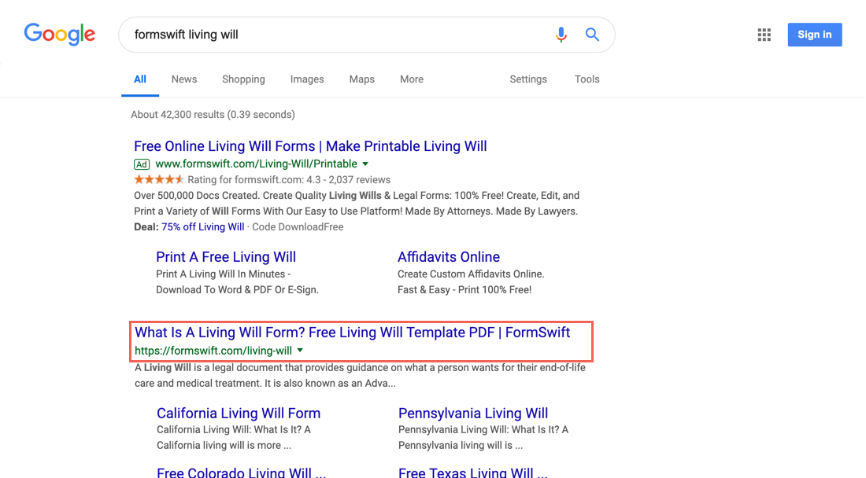
Step 2. Find the Step-by-Step Section
Scroll down until you see the Step-by-Step section on the page. It should look something like below.
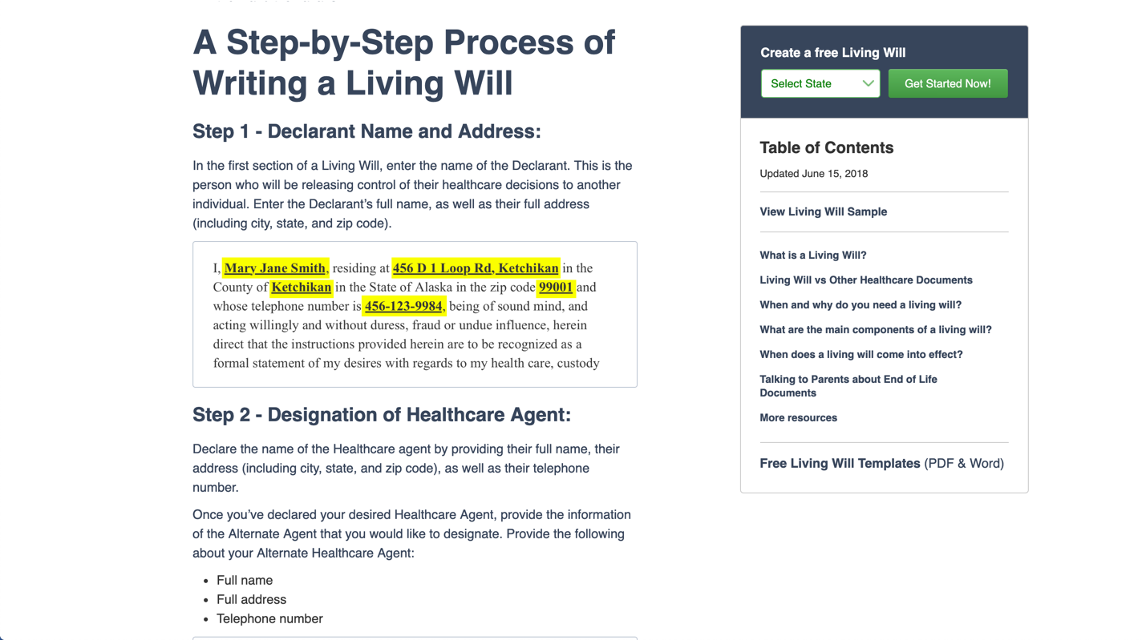
Step 3. Follow the Steps in the Guide
Review each step and decide what is the best way to fill out for your specific scenario. If you find these steps helpful, feel free to share the guide by providing the proper attribution with a link to formswift.com/livng-will.
LIVING WILL
ADVANCE HEALTH CARE DIRECTIVE
(________________________)

In the event that the time comes and I am incapacitated to the point that I am no longer able to actively take part in decisions for my own life, and I am unable to direct my healthcare physician as to my own medical care, I hereby authorize this Living Will as my Advance Health Care Directive to stand as a testament of my wishes.

I, ________________________, residing at ________________________, ________________________ in the County of ________________________ in the State of ________________________ in the zip code ________________________ and whose telephone number is ________________________, being of sound mind, and acting willingly and without duress, fraud or undue influence, herein direct that the instructions provided herein are to be recognized as a formal statement of my desires with regards to my health care, custody and medical treatment, and as such I hereby voluntarily declare and make this designation with regards to my Living Will (aka Advance Health Care Directive and/or Health Care Proxy). These instructions and directives shall be binding upon all involved to the fullest extent allowable by law.

DESIGNATION OF HEALTH CARE ADVOCATE

I herein designate ________________________, residing at ________________________, ________________________, ________________________ ________________________ and whose telephone number is ________________________, as my advocate and agent to make any and all health care decisions on my behalf should I ever be diagnosed with a terminal illness, disease, injury, or should I become incapacitated or permanently unconscious (in a coma or persistent vegetative condition) where I would remain permanently unable to make decisions.

ADVOCATE'S GENERAL POWERS

My health care advocate or agent shall have the power to make health care, custody and medical treatment decisions on my behalf if my attending and/or primary physician makes the determination that I am unable to make said decisions.

I have specific directives regarding the delivery of medical care in certain health care conditions. Therefore, I wish to direct my medical treatment by way of the following conditions:

LIFE-SUSTAINING MEDICAL TREATMENT

Should any of the aforementioned events occur, I wish to leave the following directives regarding the treatment and procedures which may be used, withheld or withdrawn:

- I wish to ________________________ cardiac resuscitation (CPR) in an attempt to try and prolong my life.

- I wish to ________________________ life-support (e.g., respirators, ventilators) used in an effort to replace or support my natural breathing.

- I wish to ________________________ tube feeding or any other artificial or invasive form of nutrition (food) or hydration (water).

- I wish to ________________________ blood or blood products.

- I wish to ________________________ any form of surgery or invasive diagnostic tests.

- I wish to ________________________ kidney dialysis.

- I wish to ________________________ antibiotics or medication in an attempt to try and prolong my life.

I understand that if I do not specifically indicate my preferences above regarding any of the forms of treatment, I may be subjected to that form of treatment.

COMFORT AND PAIN RELIEF

With regards to the aforementioned medical situations outlined above, I herein provide the following directives pertaining to the comfort care and pain relief:

- I wish to ________________________ maximum pain relief medication.

- I wish to ________________________ maximum pain relief medication if it may unintentionally hasten my death.

- I wish to ________________________ maximum pain relief medication if it may result in temporary addiction should I survive, recover or rebound from my current conditions and/or extended hospital stay.

ADVOCATE'S OBLIGATION

My appointed advocate or agent shall make health care decisions on my behalf in accordance with my other wishes known to my advocate and/or agent. To the extent that my wishes are not known to my advocate or agent, my advocate or agent shall make the necessary health care decisions for me in accordance to what my advocate deems to be in my best interest. In determining those best interests, my advocate shall take into consideration my personal values to the extent known to the advocate.

END OF LIFE DECISIONS

I direct my health care advocate, health care provider and others who may be involved in my health care, to withhold or withdraw treatment in accordance with the choice I have indicated below:

DECLARANT STATEMENT AND SIGNATURE

This instrument shall be governed by the laws of ________________________, and I respectfully request that it be honored in any state in which I may reside at the time that this Living Will shall take effect.

By signing below, I certify that I am fully aware and completely understand the contents of this document, and that I am of sound body and mind. Furthermore, I am of the legal age of consent and not under undue influence, fraud or duress.

WITNESSES

This Living Will (aka Advance Health Care Directive and/or Health Care Proxy) must be signed by two adult witnesses that are personally present when I sign this document.

WITNESS STATEMENT

I certify that I am of 18 years of age or older and that I know the Declarant personally or have been provided with valid identification to his/her identity and believe him/her to be of sound mind and under no duress, fraud or undue influence. The Declarant has had the opportunity to read this document and has signed or acknowledged his/her signature or mark in my presence.

Under penalty of perjury I declare that I am not related to the Declarant by blood, marriage or adoption, nor am I responsible for his/her medical care or costs. Furthermore, I am not the primary or attending physician or an employee of the physician or other health care provider or current care facility for the Declarant. I also attest that I am not an employee of any life or health insurance provider, nor am I involved with the direct physical care of the Declarant. Further, I have no claim to the Declarant's estate, and to the best of my knowledge, I am not entitled to any part of the Declarant's estate upon his/her death with any will now in existence or by any other process of law.

__________________________________________________________ __________________
(Declarant Signature) (Date)

1st Witness: | _______________________________________ _________________  (Witness Signature) (Date)
 | ________________________
Address: | ________________________
 | ________________________, ________________________ ________________________
Telephone: | ________________________

2nd Witness: | ______________________________________ _________________  (Witness Signature) (Date)
 | ________________________
Address: | ________________________
 | ________________________, ________________________ ________________________
Telephone: | ________________________

NOTARY PUBLIC
CERTIFICATE OF ACKNOWLEDGMENT

STATE OF ________________________ | )
 | )
COUNTY OF ________________________ | )

On this date, ___________________________, the Declarant, ________________________, personally appeared before me and having provided verifiable identification to be the Declarant whose name is subscribed to this instrument and acknowledged to me that s/he executed the same in his/her capacity, and that by his/her signature on the instrument, executed the instrument.

I declare that s/he appears to be of sound mind and not under or subject to duress, fraud or undue influence, that s/he acknowledges the execution the same to be his/her voluntary act and deed, and that I am not the advocate, attorney-in-fact, proxy, surrogate, or a successor of any such, as designated within this document, nor do I hold any interest in his/her estate through a Will or by any other means or process of law.

WITNESS my hand and seal.

____________________________________________________
(Notary Signature)

My Commission Expires: _______________________________
(Date)

