Power of Attorney Instructions
Your power of attorney template starts on the next page. To get step-by-step instructions on how to fill out this power of attorney, please follow the instructions below.
Step 1. Search for “FormSwift Power of Attorney”
Search for “formswift power of attorney” on https://google.com and click the link that reads https://formswift.com/power-of-attorney.
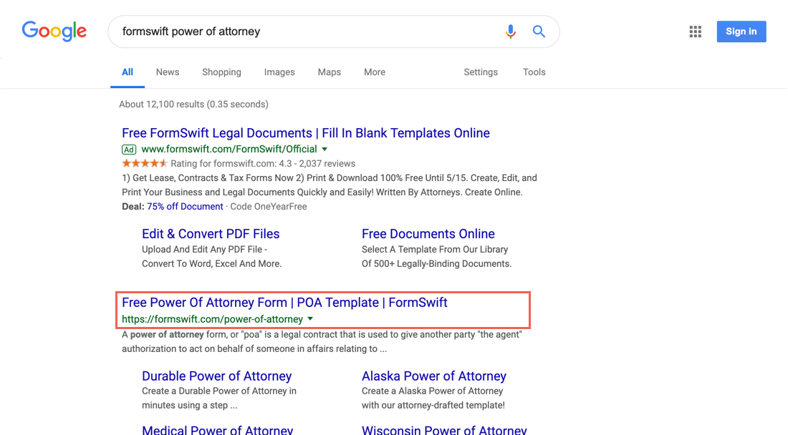
Step 2. Find the Step-by-Step Section
Scroll down until you see the Step-by-Step section on the page. It should look something like below.
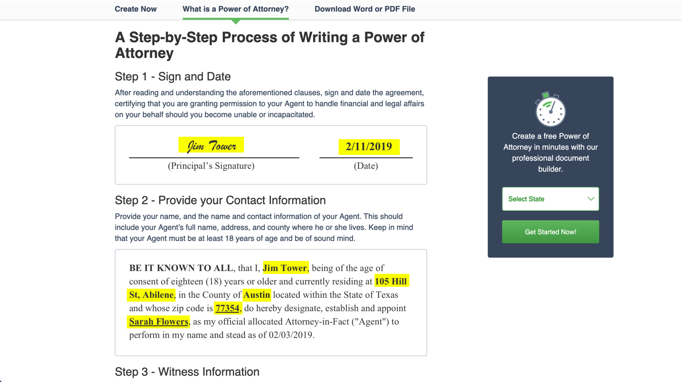
Step 3. Follow the Steps in the Guide
Review each step and decide what is the best way to fill out for your specific scenario. If you find these steps helpful, feel free to share the guide by providing the proper attribution with a link to formswift.com/power-of-attorney.
DURABLE POWER OF ATTORNEY

NOTICE TO THE PRINCIPAL: THE PURPOSE OF THIS POWER OF ATTORNEY IS TO GIVE THE PERSON YOU DESIGNATE (YOUR "AGENT") BROAD POWERS TO HANDLE YOUR PROPERTY, WHICH MAY INCLUDE POWERS TO SELL OR OTHERWISE DISPOSE OF ANY REAL OR PERSONAL PROPERTY WITHOUT ADVANCE NOTICE TO YOU OR APPROVAL BY YOU.
THIS POWER OF ATTORNEY DOES NOT IMPOSE A DUTY ON YOUR AGENT TO EXERCISE GRANTED POWERS, BUT, WHEN POWERS ARE EXERCISED, YOUR AGENT MUST USE DUE CARE TO ACT FOR YOUR BENEFIT AND IN ACCORDANCE WITH THIS POWER OF ATTORNEY.
YOUR AGENT MAY EXERCISE THE POWERS GIVEN HERE THROUGHOUT YOUR LIFETIME, EVEN AFTER YOU BECOME INCAPACITATED, UNLESS YOU EXPRESSLY LIMIT THE DURATION OF THESE POWERS OR YOU REVOKE THESE POWERS OR A COURT ACTING ON YOUR BEHALF TERMINATES YOUR AGENT'S AUTHORITY.
YOUR AGENT MUST [KEEP YOUR FUNDS SEPARATE FROM YOUR AGENT'S FUNDS.] ACT IN ACCORDANCE WITH YOUR REASONABLE EXPECTATIONS TO THE EXTENT ACTUALLY KNOWN BY YOUR AGENT AND, OTHERWISE, IN YOUR BEST INTEREST, ACT IN GOOD FAITH AND ACT ONLY WITHIN THE SCOPE OF AUTHORITY GRANTED BY YOU IN THE POWER OF ATTORNEY.
THE LAW PERMITS YOU, IF YOU CHOOSE, TO GRANT BROAD AUTHORITY TO AN AGENT UNDER POWER OF ATTORNEY, INCLUDING THE ABILITY TO GIVE AWAY ALL OF YOUR PROPERTY WHILE YOU ARE ALIVE OR TO SUBSTANTIALLY CHANGE HOW YOUR PROPERTY IS DISTRIBUTED AT YOUR DEATH. BEFORE SIGNING THIS DOCUMENT, YOU SHOULD SEEK THE ADVICE OF AN ATTORNEY AT LAW TO MAKE SURE YOU UNDERSTAND IT.
A COURT CAN TAKE AWAY THE POWERS OF YOUR AGENT IF IT FINDS YOUR AGENT IS NOT ACTING PROPERLY.
IF THERE IS ANYTHING ABOUT THIS FORM THAT YOU DO NOT UNDERSTAND, YOU SHOULD ASK A LAWYER OF YOUR OWN CHOOSING TO EXPLAIN IT TO YOU.

(Principal's Signature) |  | (Date)

________________________

BE IT KNOWN TO ALL, that I, ________________________, being of the age of consent of eighteen (18) years or older and currently residing at ________________________, ________________________, in the County of ________________________ located within the State of ________________________ and whose zip code is ________________________, do hereby designate, establish and appoint ________________________, as my official allocated Attorney-in-Fact ("Agent") to perform in my name and stead as of ________________________.

The appointed Agent to the Durable Power of Attorney, as stipulated within the aforementioned instrument, does not have the right to transfer nor convey any of the Principal's property, now owned or later acquired, to himself or herself, the Agent's family member or any associate without full and adequate consideration nor accept a gift of the Principal's property unless otherwise stipulated within this Durable Power of Attorney. In the event that the designated Agent should transfer any of the principal's Property to his/herself without precise detailed written authorization contained with the Durable Power of Attorney, the Agent could be prosecuted, to the fullest extent allowable by law, for fraud and/or embezzlement. Should it be determined that the Principal was or is 65 years of age or older at the time said property was illegally transferred to the Agent without precise detailed written authority, the Agent could be prosecuted pursuant to and in accordance with the federal and/or state Elder Abuse Laws of ________________________. In addition to criminal prosecution, the Agent may be sued in civil court as well.

This DURABLE POWER OF ATTORNEY, shall not be affected by subsequent incapacity of the Principal.

I do hereby revoke and/or rescind any "General Power of Attorney" signed by me that was previously in effect. HOWEVER, this does not revoke nor invalidate any Power of Attorney that may be directly related to any Advance Health Care Directive previously signed by me.

THEREFORE, it is my wish that my Agent shall maintain full power and authority to act on my behalf with respect to the following subjects:

My Agent's powers shall include the authority to:

The Agent shall have complete authority to manage and conduct all my affairs, as initialed above and to exercise all of my legal rights and powers, including any and all rights and powers that I may acquire in the future regarding the categories above.

THEREFORE, let it be known that this Power of Attorney shall be interpreted as a Durable Power of Attorney, and as such the specific intentions are not meant to limit or impede the powers conferred with regards to this Durable Power of Attorney in any way.

IN ADDITION, any right or authority that shall be extended to my Agent by way of this instrument shall be limited to the degree deemed necessary as a means to prevent this Power of Attorney that would create or trigger: (i) any portion of my current or any future acquired assets to become subject to any general power of appointment by my Agent, (ii) my Agent to have any occurrences of ownership with regards to any life insurance policies that I may purchase or possess on the life of my Agent, and (iii) any portion of my income to become taxable to my Agent.

FURTHERMORE, let it be known that my Agent shall not be held liable, in any manner or aspect, for any loss which may result from any judgment error made in good faith while performing on my behalf. However, my Agent could be held and shall be held liable for any "willful misconduct or failure to act in good faith" in the performance of their fiduciary responsibilities as my Agent in accordance with this Durable Power of Attorney.

I hereby authorize my designated Agent to indemnify and hold harmless any third party who accepts and acts under this instrument.

IN SO MUCH, that my Agent carries out and abides by my wishes, s/he shall be entitled to reasonable compensation for any of his/her services provided as my Agent.

IN ADDITION, my Agent shall be reimbursed of any and all reasonable expenses which may have been incurred in connection with the aforementioned Power of Attorney.

LASTLY, my Agent shall furnish and deliver a comprehensive report for any and all accounts controlled or any activities performed in accordance with federal and state laws, and in whatever manner as instructed or requested by me or any authorized personal Agent, governmental bureau or official organization which may be acting on my behalf.

THE AFOREMENTIONED Durable Power of Attorney shall become effective immediately following the signing of this instrument on the date indicated. This instrument shall not be affected should I become disabled or be deemed mentally incompetent, except as may otherwise be provided or stipulated herein or by applicable state statute. This Durable Power of Attorney shall remain in effect until my demise or is revoked by me through written notification to my Agent.

Dated ________________________.

(Principal Signature - ________________________)

(Agent Signature - ________________________)

(Signature of Witness #1 - ________________________)

(Signature of Witness #2 - ________________________)

STATE OF ________________________,

COUNTY OF ________________________

On __________________ the aforementioned parties appeared before me, a Notary Public, for the above state and county, and is known to me or provided photo identification and that such individuals executed the foregoing instrument, and being duly sworn, such individuals acknowledged that s/he executed said instrument for the purpose therein contained of his/her free will and voluntary act.

(SIGNATURE NOTARY PUBLIC)

My Commission expires: ______________________________

WITNESS VERIFICATION

________________________, on the abovementioned date, acknowledges and declared that s/he appointed ________________________, in our presence, to be his/her Power of Attorney. We, the below listed witnesses, in his/her presence and at his/her request, and in the presence of each other, verify and confirm to the same and hereby sign our names as attesting witnesses.

(Signature of Witness #1)

________________________
________________________
________________________, ________________________ ________________________
________________________

(Signature of Witness #2)

________________________
________________________
________________________, ________________________ ________________________
________________________

SIGNATURE OF NOTARY PUBLIC
Signed (or subscribed or attested) before me on ______________________________(date) by ________________________.

____________________________________________ Notary Seal
Notary Signature

SIGNATURE OF NOTARY PUBLIC

Signed (or subscribed or attested) before me on ______________________________(date) by ________________________.

____________________________________________ Notary Seal
Notary Signature

NOTICE TO PRINCIPAL REGARDING INDIVIDUAL EXECUTING
POWER OF ATTORNEY

The implementation of a Power of Attorney is an important legal document, and should not be undertaken lightly. With the signing of the Durable Power of Attorney, you are hereby authorizing another individual to act on your behalf. There are significant facts that you should be aware of and familiar with prior to you signing the aforementioned Power of Attorney.

- Your appointed Agent (the Attorney-in-Fact) shall have no obligation to perform unless both you and your Agent shall agree otherwise in writing.

- The above Durable Power of Attorney provides your Agent with the authority to administer, dispense with, trade, sell and transfer your real and personal property, as well as the option to use said property as security should your Agent borrow money on your behalf, unless otherwise provided in writing within this Durable Power of Attorney.

- As your Agent, s/he shall have the right to receive reasonable compensation for any and all functions, activities and services provided and/or contained within the aforementioned Power of Attorney unless you provide otherwise within this instrument.

- Please note that any power you convey to your Agent shall continue to endure your entire lifetime, unless a shorter duration of time is stipulated or should you otherwise terminate your authorized Durable Power of Attorney.

- The powers provided to the Agent within the aforementioned Power of Attorney shall continue to exist even if you should become mentally or physically incapacitated and thus unable to make decisions with regards to the management of assets, finances, and property (real and personal), unless otherwise stipulated within said Durable Power of Attorney.

- Changes or corrections to any of the terms contained within the aforementioned Power of Attorney can be made only by the execution of a new Power of Attorney, or through the execution of an amendment by way of the same formalities as the original. The Principal of the Durable Power of Attorney shall maintain the right to change, revoke and/or terminate this agreement at any time as long as said Principal is deemed competent.

- The aforementioned Power of Attorney must be dated and acknowledged before a notary public and signed by two (2) witnesses. Witnesses to the aforementioned Power of Attorney must be deemed mentally competent and will also be required to witness the principal's signing of the Power of Attorney and/or the principal's signing/acknowledgment of his/her signature. Any legal document or instrument that could affect a principal's real property should be acknowledged before a notary public for ease of recording.

- A Power of Attorney should be reviewed and read carefully prior to signing. Once the instrument becomes effective, said Durable Power of Attorney shall provide your Agent the power and authority to manage any and all property you now own or may acquire in the future. A Durable Power of Attorney is an important instrument/document, and as such, should you not understand any item or provision contained therein, you should seek the assistance of an attorney or qualified individual to advise you accordingly.

(Principal's Signature) |  | (Date)

________________________
________________________
________________________, ________________________ ________________________

NOTICE TO AGENT REGARDING INDIVIDUAL ACCEPTING APPOINTMENT
AS ATTORNEY-IN-FACT

Acceptance of or the agreement to act as the Agent (Attorney-in-Fact) with regards to the aforementioned Power of Attorney, you undertake the fiduciary and other legal duties and/or responsibilities of a Agent. These duties/responsibilities include:

- The Agent shall have the fiduciary and legal duty to act solely in the interest of the principal; with faithfulness, devotion, trustworthiness, dependability, care, competence and/or diligence as required to avoid any misunderstandings or conflicts of interest.

- The Agent shall have the fiduciary and legal duty to maintain and to keep account of any and all transactions, dealings and communications that transpired on behalf of the Principal named in the Durable Power of Attorney. Such transaction records shall include, but are not limited to, receipts for purchases, sales, transfers and deposits, disbursements, collection of money owed, payment of bills or liabilities to or for the principal, and any other dealings or transactions with regards to any of the principal's assets or liabilities.

- In the event that the principal should appoint a separate Health Care Agent to administer any health care decisions, the Agent to this Durable Power of Attorney shall cooperate fully with the principal's duly appointed Health Care Agent in making decisions pursuant with the principal's desires/wishes or that which is deemed in the best interest of the principal.

- The Agent shall have the fiduciary and legal duty related to maintain and uphold any estate plan that the principal may have in effect, if any.

- The Agent shall have the fiduciary and legal duty to preserve the principal's property separate and well-defined from any other property that the Agent may have under his/her power and possession.

- The Agent shall have the fiduciary and legal duty to cease and/or terminate actions as Agent (Attorney-in-Fact) related to the aforementioned Durable Power of Attorney upon the occurrence of any of the following items:

- The Principal's demise;
- The cancellation or revocation of aforementioned Durable Power of Attorney;
- The onset of any date which may be contained within the stipulated Durable Power of Attorney, stating or stipulating a date terminating the Durable Power of Attorney, if any; or
- No additional action required under the Durable Power of Attorney.

- In the event that the Agent (Attorney-in-Fact) is the spouse of the principal, said Durable Power of Attorney shall be terminated upon legal separation or dissolution of the marriage.

- At any time should the Agent willfully violate, misuse, exploit, mishandle or abuse the power or authority conveyed or granted under this Durable Power of Attorney, you, as the Agent, may be held accountable, responsible and/or liable for any said intentional actions pursuant to federal and state laws governing this Durable Power of Attorney.

- In addition, as the Agent (Attorney-in-Fact), you shall have the right to pursue and obtain legal advice should you not understand any stipulated duties and responsibilities as Agent or any provisions contained within the Durable Power of Attorney.

As the appointed Agent to the Durable Power of Attorney, as stipulated within the aforementioned instrument, you do not have the right to transfer nor convey any of the principal's property, now owned or later acquired, to yourself, family member or any associate without full and adequate consideration nor accept a gift of the principal's property unless otherwise stipulated within the aforementioned Durable Power of Attorney. In the event that the designated Agent should transfer any of the principal's property to his/herself without precise detailed written authorization contained with the Durable Power of Attorney, the Agent could be prosecuted, to the fullest extent allowable by law, for fraud and/or embezzlement. Should it be determined that the principal was or is 65 years of age or older at the time said property was illegally transferred to the Agent without precise detailed written authority, the Agent could be prosecuted pursuant to and in accordance with the federal and/or state Elder Abuse Laws of ________________________. In addition to criminal prosecution, the Agent may be sued in civil court as well.

THEREFORE, I hereby acknowledge that I have read the foregoing notice and that I understand all contained fiduciary and legal duties and responsibilities that I hereby assume by action of signing as the Agent (Attorney-in-Fact) in accordance with the terms and conditions contained within the Durable Power of Attorney.

(Agent's Signature) |  | (Date)

________________________
________________________
________________________, ________________________ ________________________
________________________

